Task Requirement

00. Getting started

For the tasks in this lab, you will be using the files found in [this archive](https://ocw.cs.pub.ro/courses/_media/ii/labs/s2/04/tasks/lab4.zip), which contains a NodeJS application that creates an API for adding books in a library over a PostgreSQL database. The architecture of the application is shown in the image below. It is composed of a backend (or API), a database, and an administration component for the database.

[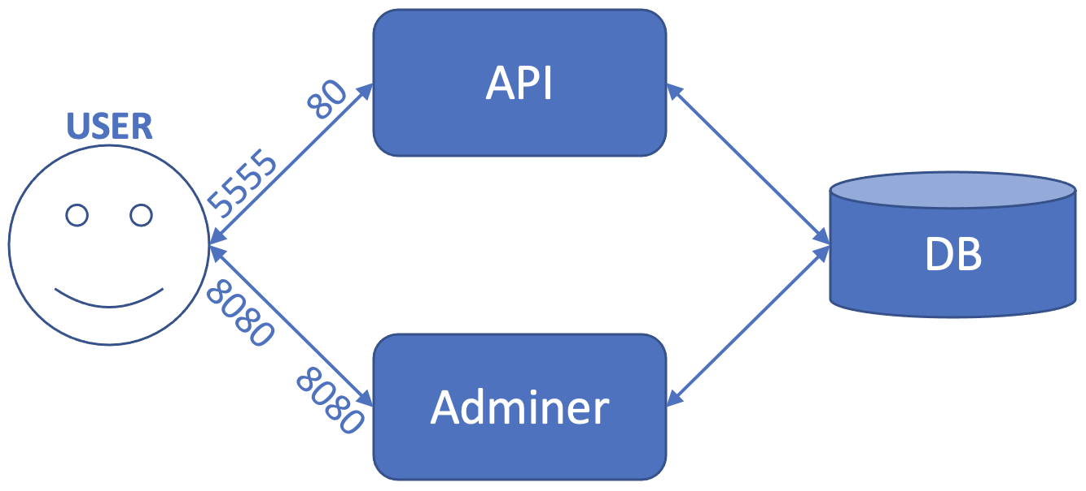](https://ocw.cs.pub.ro/courses/_media/ii/labs/s2/04/tasks/arch.png)

In order to solve the tasks, you need to have Docker installed, or you need to use [Play with Docker](https://labs.play-with-docker.com/).

**This is the overall requirement.**

1. write the entire configuration described below in a Docker Compose file called ***docker-compose.yml***
2. deploy the configuration from the ***docker-compose.yml*** file using ***docker compose -f docker-compose.yml up -d***
3. use Postman and Adminer to verify that everything works just as before
4. stop all the containers using ***docker compose -f docker-compose.yml down***
5. remove the remaining volume
6. Compose a multi-container application with one single **docker-compose** file

Subtasks

1. create a bridge network called ***lab4-db-network***
2. create another bridge network called ***lab4-adminer-network***
3. create a volume named ***lab4-db-volume***
4. from the parent folder of ***backend***, launch a container ***in the background*** for a database with the following features:
   1. a bind mount will be attached that will map between the ***"$(pwd)"/database/init-db.sql*** file on the local machine (this will be the source to the bind mount flag and can be found in the lab archive) and the ***/docker-entrypoint-initdb.d/init-db.sql*** file in the container to be run (this will be the destination)
   2. attach the previously-created ***lab4-db-volume*** volume (as source) to the ***/var/lib/postgresql/data*** path in the running container (as destination)
   3. the container will be part the previously-created ***lab4-db-network*** network
   4. the following environment variables will be specified (in a ***docker run*** command, this is done as follows: ***docker run -e NAME=value***):
      1. variable ***POSTGRES_USER*** with value ***admin***
      2. variable ***POSTGRES_PASSWORD*** with value ***admin***
      3. variable ***POSTGRES_DB*** with value ***books***
   5. the container will be called ***lab4-db***
   6. the container will run the ***postgres*** image from the official register
5. add the ***lab4-db*** container to the ***lab4-adminer-network*** network
6. launch a container ***in the background*** for a database admin with the following features:
   1. the container will expose port 8080 and map it to 8080 on the local machine
   2. the container will be called ***lab4-adminer***
   3. the container will be part the previously-created ***lab4-adminer-network*** network
   4. the container will run the ***adminer*** image from the official register
7. start a container ***in the background*** based on the previously-created ***lab4-api-image*** image, with the following features:
   1. the container will be part of the previously-created ***lab4-db-network*** network
   2. the following environment variables will be specified:
      1. variable ***PGUSER*** with value ***admin***
      2. variable ***PGPASSWORD*** with value ***admin***
      3. variable ***PGDATABASE*** with the value ***books***
      4. variable ***PGHOST*** with value ***lab4-db***
      5. variable ***PGPORT*** with value ***5432***
   3. the container will be called ***lab4-api***
   4. the container will expose port 80 and map it to port 5555 on the local machine

02. Testing a web application using Postman

The application started earlier is a web application that does not have a graphical interface (i.e., a frontend). For this reason, it can only be tested by sending HTTP requests using a tool such as [Postman](https://www.postman.com/). We will now show how to use Postman to connect to a web application backend.

In the Postman application, we can create the two types of requests that we want to test:

***GET*** - requests information from the backend (in our case, the list of books in the library)

***POST*** - sends information to the backend (in our case, adds a book to the library).

The steps to accomplish this are outlined below. Firstly, once we have opened the Postman application, we press the ***+*** button, as can be seen in the image below (the button is circled in red).

[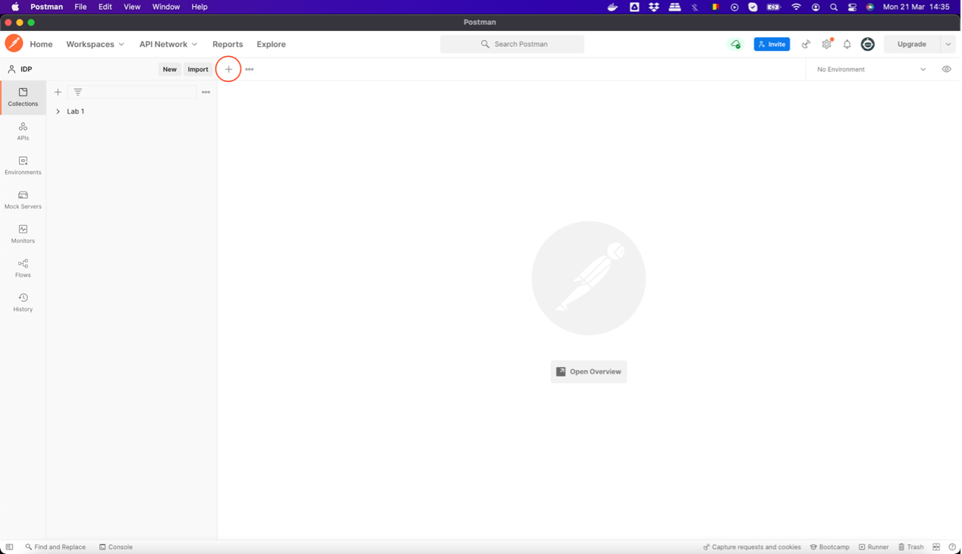](https://ocw.cs.pub.ro/courses/_media/ii/labs/s2/04/tasks/screen1.png)

Next, we select the ***HTTP Request*** option, as shown below.

[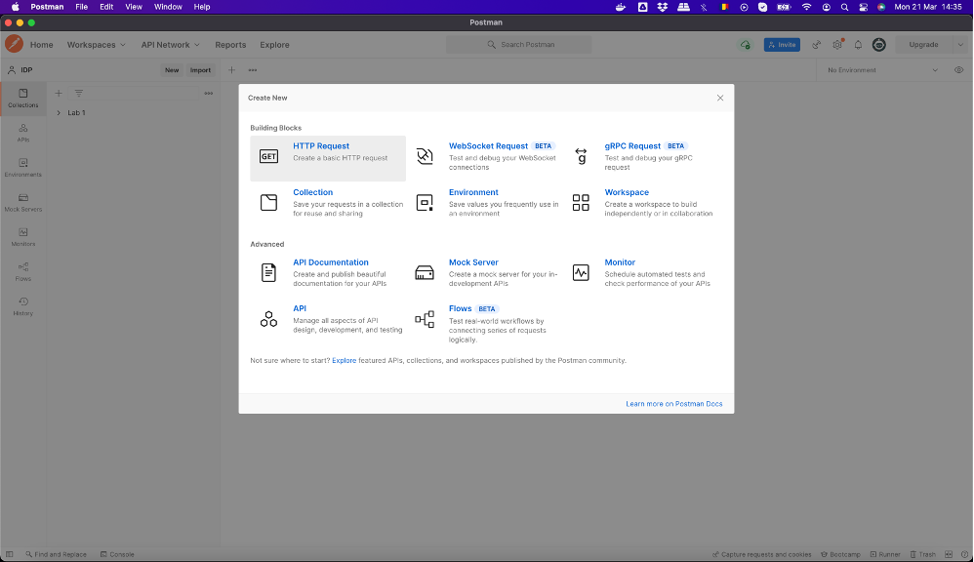](https://ocw.cs.pub.ro/courses/_media/ii/labs/s2/04/tasks/screen2.png)

We add the first request, whose type should be ***GET***. In the address bar, we write ***localhost:5555/api/books/*** and then we press the ***Send*** button (shown in red in the image below).

[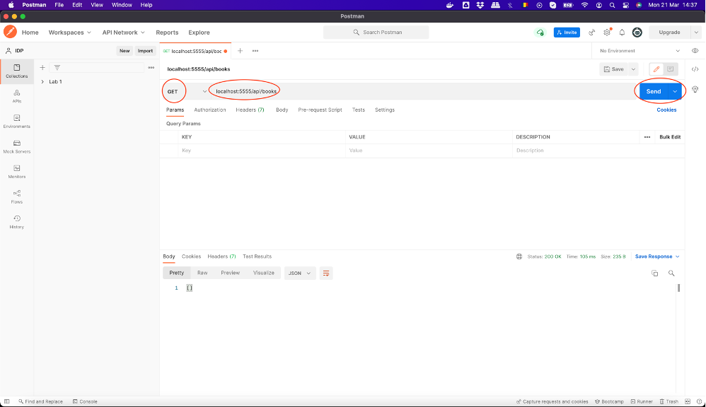](https://ocw.cs.pub.ro/courses/_media/ii/labs/s2/04/tasks/screen3.png)

Once the request is sent and everything is in order, we should receive a reply with the status ***200 OK*** (circled in the image below), which contains an empty string (because there are currently no books in the library), as shown below.

[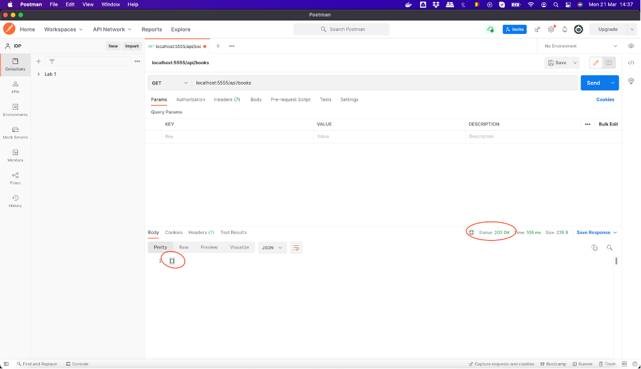](https://ocw.cs.pub.ro/courses/_media/ii/labs/s2/04/tasks/screen4.png)

Next, we can create a ***POST*** request. We start by pressing the circled ***+*** button in the image below.

[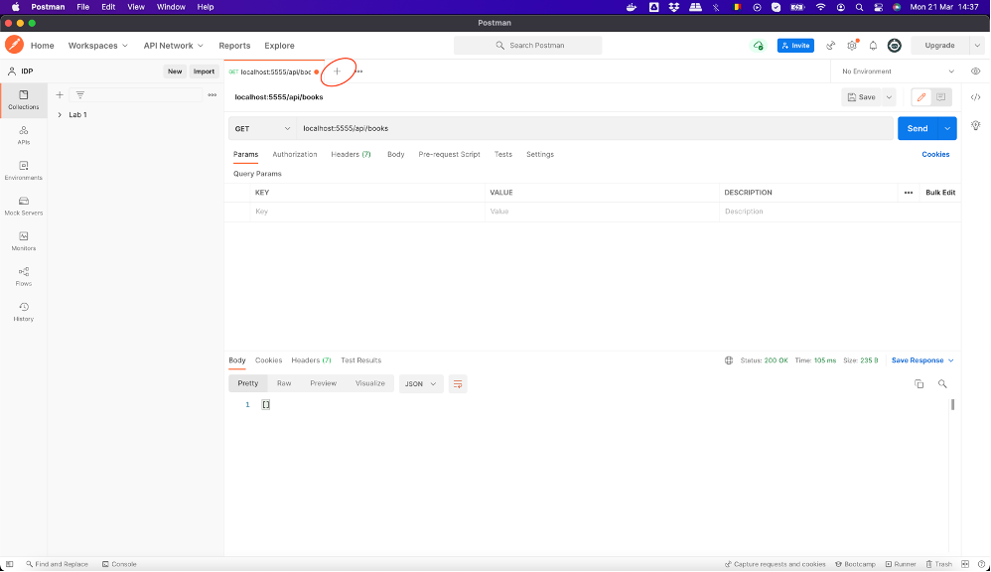](https://ocw.cs.pub.ro/courses/_media/ii/labs/s2/04/tasks/screen5.png)

Next, we set the request type to ***POST*** and then put the same address as before.

[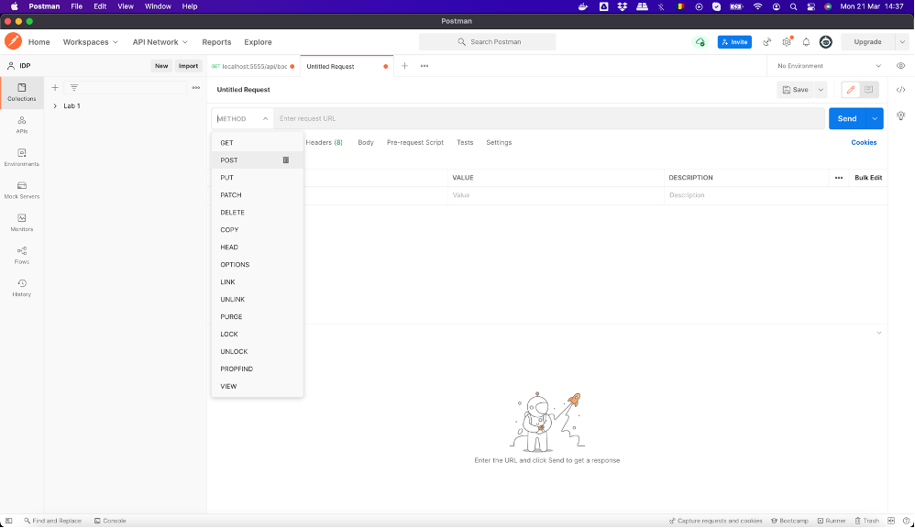](https://ocw.cs.pub.ro/courses/_media/ii/labs/s2/04/tasks/screen6.png)

Because we are now adding a book, we need to place the book information in the ***POST*** request we are making. This is done by selecting the ***Body*** component of the request (circled in red in the image below), marking the data as ***Raw*** and ***JSON*** (also in red in the image) and adding the book information in JSON format (see below an example for “Harry Potter and the Prisoner of Azkaban”):

[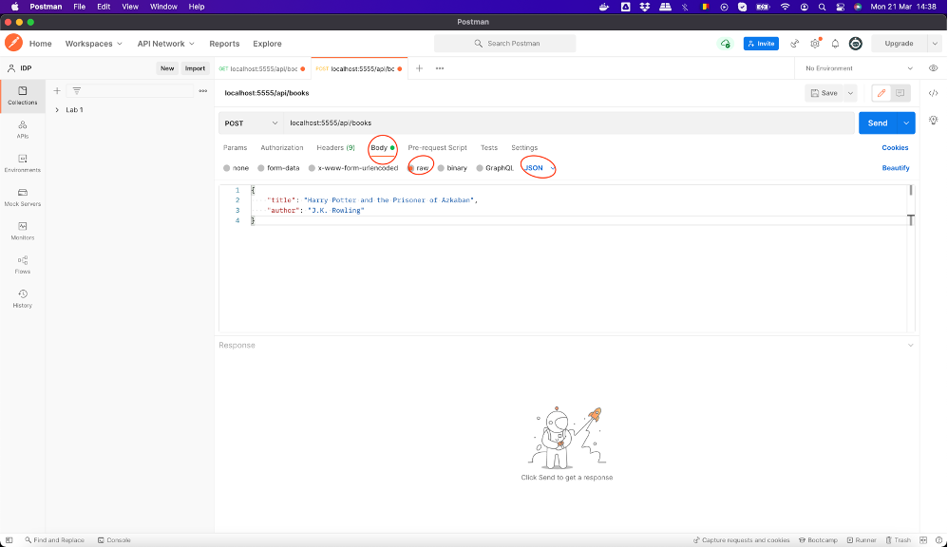](https://ocw.cs.pub.ro/courses/_media/ii/labs/s2/04/tasks/screen7.png)

When we press the ***Send*** button, if everything is fine, we will receive a reply with the status ***200 OK*** and the ID of the newly-added book, as can be seen in the image.

[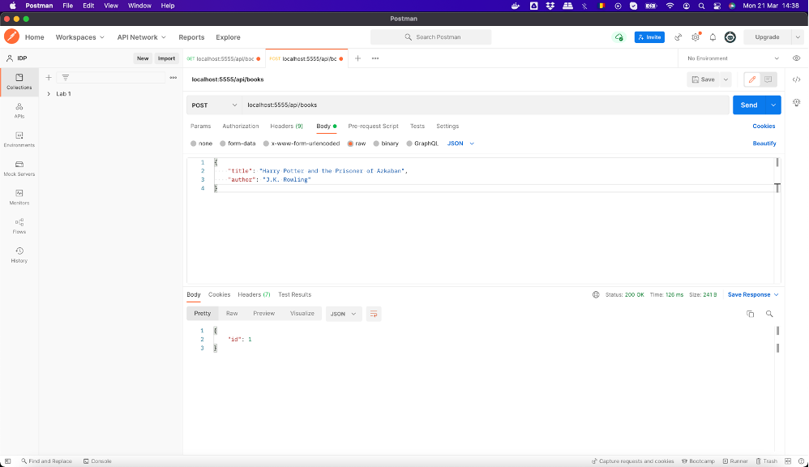](https://ocw.cs.pub.ro/courses/_media/ii/labs/s2/04/tasks/screen8.png)

Finally, if we run the ***GET*** request again, we can check the existence of the book we added in the library.

[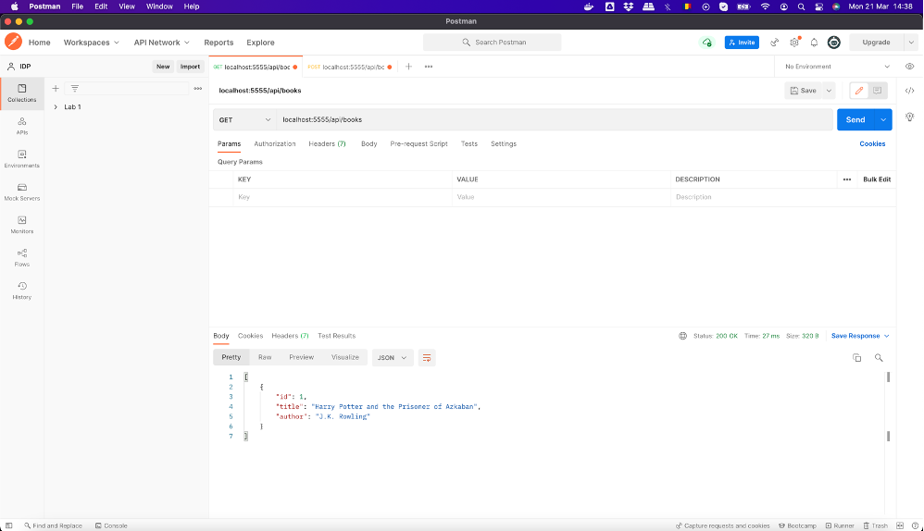](https://ocw.cs.pub.ro/courses/_media/ii/labs/s2/04/tasks/screen9.png)

If you are using Play with Docker instead of running on your own computer, you need to replace the ***localhost:5555*** part of the address with the VM's actual address (see [lab 3](https://ocw.cs.pub.ro/courses/ii/labs/s2/03) for a reminder on how to do this).

Subtasks

1. install Postman
2. send a ***GET*** request to your application based on the steps above and check that it returns ***200 OK*** and an empty list of books
3. add a book of your choosing in the library using a ***POST*** request based on the steps above and check that it returns ***200 OK***
4. send a ***GET*** request again and check that you can see the book you just added

03. Testing for data persistence

Subtasks

1. stop and delete the three containers started at exercise 1
2. start them again using the same commands given at exercise 1
3. send a ***POST*** request using Postman and verify that the book you added at exercise 2 is still in the library

04. Administrating a database

Subtasks

1. go to the Adminer interface on [http://localhost:8080](http://localhost:8080/) (or see [lab 3](https://ocw.cs.pub.ro/courses/ii/labs/s2/03) if you are working on Play with Docker)
2. log into the database using the following details:
   * + 1. System: PostgreSQL
       2. Server: lab4-db
       3. Username: admin
       4. Password: admin
       5. Database: books
3. check that you can observe a table called ***books*** and click on it
4. click the ***Select data*** button to see the books already in the database (you should see the book you previously added)
5. click the ***New item*** button and add a new book (you should only fill in the ***title*** and ***author*** text boxes and then press ***Save***)
6. using Postman, send a ***GET*** request and check that the backend also returns the book you added in Adminer

05. Cleaning up

Subtasks

1. stop and remove the three containers created previously
2. remove the two networks created previously
3. remove the volume created previously

*If you use docker compose, the actions above will be automatically done with docker compose down.*